Announces its Spring 2024 Lecture

Wednesday, April 17th, 2024
8:00 PM via Zoom
All Wars Memorial to Colored Soldiers and Sailors (1934), Logan Circle, Philadelphia

Black History in the Philadelphia Landscape:
Deep Roots, Continuing Legacy

A Book Talk with Author
Amy Jane Cohen

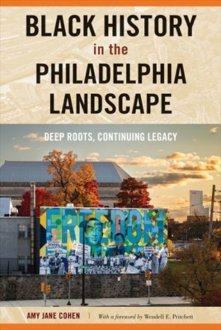
Amy Jane Cohen will discuss the long and influential presence of African Americans in Philadelphia and how this history is reflected in monuments, markers and murals. After giving a general overview of her book, she will focus on the All Wars Memorial to Colored Soldiers located in Philadelphia’s Logan Circle.

After twenty years as a middle and high school social studies teacher, Cohen received the Southeast Pennsylvania Teacher of the Year award. In 2013, she became the Director of Education at History Making Productions where she produced the award winning film, Octavius V. Catto: A Legacy for the 21st Century. Cohen writes for Hidden City, the Pennsylvania Gazette and the Philadelphia Inquirer.

To Join Meeting: - Or Enter Zoom Meeting ID:

Event is Free Contact: Save Our Sites 2005 Cambridge Street Philadelphia, PA 19130 (215) 915-6627

